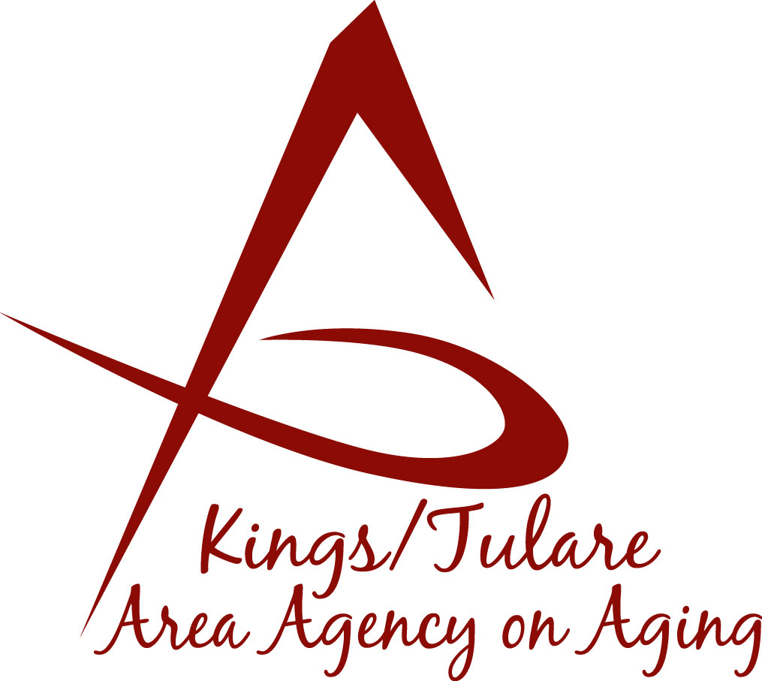ADVISORY COUNCIL AGENDA
Monday, May 13, 2019
11:00 a.m.
Cutler-Orosi Senior Center
12691 Avenue 408
Cutler, CA 93615

- Call to Order Action

- Introductions of Guests and Council Members Information

3. Public Comment 3 minutes
Any person may directly address the Council at this time on any item on the Agenda or any other items of interest to the public that are within the subject matter jurisdiction of the K/TAAA.

4. Approval of Minutes Action
Members present at the previous meeting may comment or correct minutes from the meeting held on April 22, 2019.

5. Announcements and Correspondence Information

6. Milestone Updates Information
Information regarding current and former members of the Council

7. 2018-2019 Tulare County Grand Jury Final Report Information

8. Member Handbook (Bylaws, Committees) Dr. Wood Information

9. Area Plan Update – final Information

10. Annual Report – continued discussion Information

11. Staff Reports Information
- Elder Abuse Awareness & Prevention Month
- Farmers Market Coupons
- Veterans Opportunity Day
- Introduction of Sjahari Pullom, new K/T AAA Administrative Specialist

12. Development of the June 2019 Council Agenda Information

13. Additional Member Comments Information

14. Adjourn Action
If there is no further business to attend to, members may adjourn the meeting at this time.
Notice to the Public
In compliance with the Americans with Disabilities Act, if you need special assistance to participate in this meeting, please contact Christine Tidwell at (559) 624-8063.
The disclosable public records related to this agenda are available for public inspection at the reception area of the Tulare County Human Services Government Plaza building, 5957 S. Mooney Blvd. Visalia, CA 93277

